**Why Pellets Are Better for Your Bird Than Seeds**

Nutrition is complex – making sure your birds are well-fed is not simple. When most people think of bird nutrition, they automatically think of seed. However, there is a vast difference between a typical seed diet and the nutritional requirements of birds. This is where pellets come in. Vetafarm has been manufacturing pelleted bird diets for over 30 years. We were the first in Australia to recognise that there’s a better way to feed birds, and we began producing fully balanced, extruded diets at our Wagga Wagga facility.

**Why Seeds Aren’t Enough**

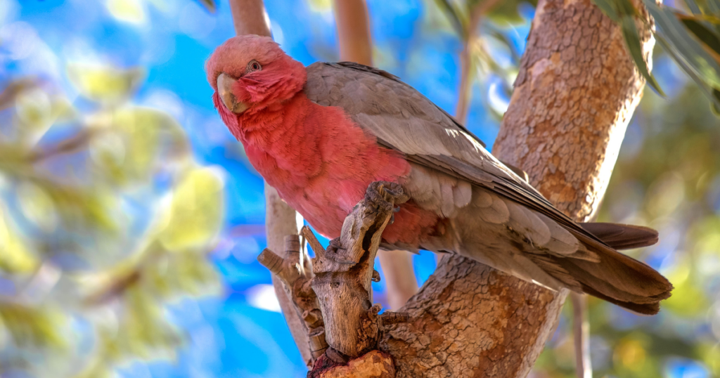

Birds in the wild have a varied diet, spending most of their days foraging on seeds, leaves, grasses, fruits, vegetables, insects, and flowers.

Replicating this at home is challenging; many bird owners rely on seed-based diets, believing they provide everything their bird needs. But the truth is, seeds alone do not offer the same complete nutritional profile and often lack key nutrients, such as essential vitamins, minerals, and amino acids, leading to deficiencies that can affect your bird’s overall health and longevity.

Common issues caused by seed-only diets include obesity, vitamin A deficiency, poor feather condition, and even liver disease. In contrast, pelleted diets are formulated to provide all the necessary nutrients in every bite, eliminating the risk of nutritional gaps.

**Pellets: The Balanced Solution**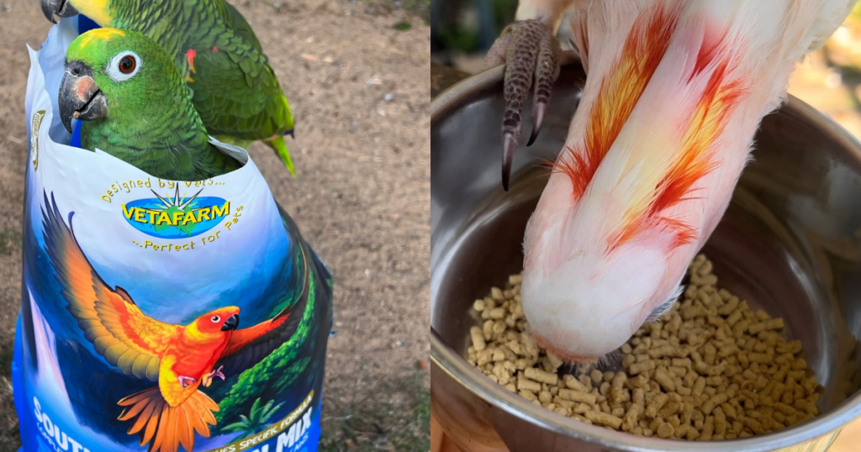@WildlifeUnleashed

Vetafarm pellets are veterinary-formulated using extensive scientific research. They meet the highest nutritional standards and provide a balanced mix of proteins, fats, vitamins, and minerals. This balance ensures every meal has the right nutrients, supporting overall health, strong immune systems, and vibrant plumage.

Unlike seeds, pellets are designed to prevent selective feeding, where birds pick out the tastiest (but often least nutritious) parts of their food. They are 100% edible, helping to minimise waste and mess, ensuring both you and your bird are getting the maximum benefit out of pellets.

Additionally, we have selected to use the extrusion process to make our pellets. This involves cooking the ingredients at high temperatures, which improves the digestibility and absorption of nutrients. This ensures that your bird is getting maximum nutritional value from their food in a form they’ll enjoy eating.

**The Importance of Variety**

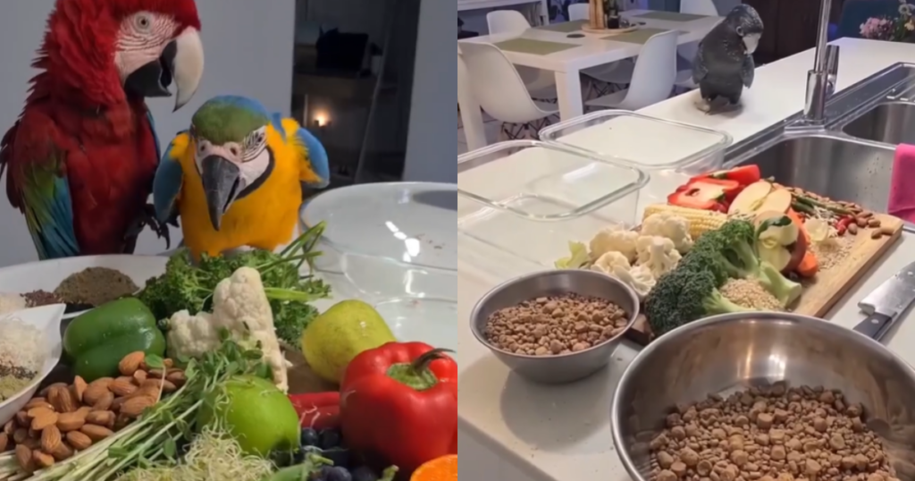  
[@Eddiesflightclub](https://www.instagram.com/Eddiesflightclub/?next=%2F)

While pellets provide a solid foundation, variety is still essential. Birds are intelligent, active creatures that benefit from a diverse diet to stimulate them mentally and physically. We recommend supplementing their pellet intake with 15% fresh fruits and vegetables, such as leafy greens, carrots, and apples. These foods add excitement to their diet and provide additional hydration and fibre.

Treats should make up no more than 5% of the diet. While birds love the occasional indulgence, limiting these to ensure they maintain a healthy weight is important. Stick to nutritious treats like Vetafarm’s Deli Stix or small pieces of fresh fruit for a rewarding snack that doesn’t compromise their health.

**Making the Switch to Pellets**

Transitioning your bird from a seed diet to pellets may take time, but it’s worth the effort. Birds can resist change, especially if they’re used to the high-fat, addictive nature of seeds. To make the switch easier, start by mixing a small amount of pellets into their regular diet, gradually increasing the proportion of pellets over time. Patience is key – some birds may take a few weeks to fully adjust to their new diet.

For picky eaters, Vetafarm offers a variety of flavours and textures in our pellet range, ensuring there’s something for every bird’s taste preferences – Nutriblend pellets make an excellent choice for conversion. And remember, persistence pays off – once your bird has transitioned to a pellet-based diet, you’ll likely notice improvements in their energy levels, feather condition, and overall health.