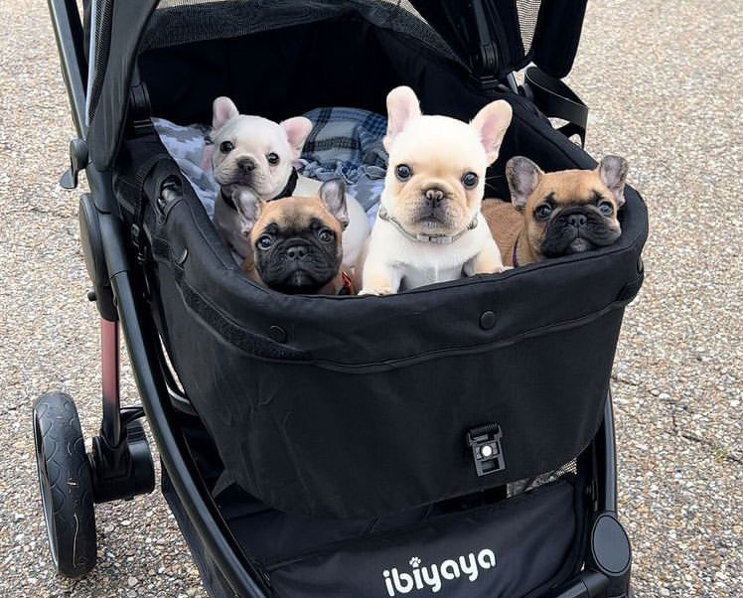

# The Ideal Bulldog Stroller: A Comprehensive Guide for Your English and French Bulldogs

**When selecting a dog stroller, owners of English and French Bulldogs need to consider specific features that cater to the unique requirements of these charming breeds. Known for their lovable but brachycephalic (flat-faced) features, Bulldogs require a stroller that not only enhances their comfort but also their safety during outings.**

Therefore, a bulldog stroller is not just an accessory; it is an essential tool that can significantly improve the quality of life for your pet.

## Key Considerations for Comfort and Design

The best dog stroller for English Bulldog or French Bulldog breeds should offer ample space and robust construction to accommodate their sturdy physique. Bulldogs are heavy for their size, and their stroller needs to support their weight while providing a smooth ride over various terrains. Look for models with reinforced frames and high-quality, durable wheels that can handle sidewalks, park paths, and more rugged surfaces.

Breathing difficulties are a well-known issue for Bulldogs due to their flat faces. It’s crucial that the stroller has excellent ventilation to ensure a cool environment, preventing overheating and providing enough air circulation to help with their breathing. A bulldog stroller should have a spacious cabin with mesh windows that allow pets to look out and interact with their surroundings, which can help reduce anxiety and increase their comfort.

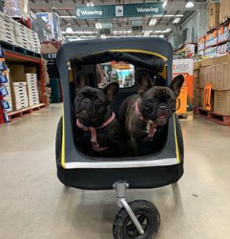

[Heavy-duty Multiple French Bulldog Stroller](https://ibiyaya.com/product/hercules-heavy-duty-pet-stroller-2-0/)

## Durability and Accessibility Features

When exploring options for a French bulldog stroller or an English bulldog stroller, consider the accessibility of the stroller. Bulldogs are not particularly agile, and those that are older or have health complications may find high entry points challenging. A low-entry stroller is advantageous as it requires minimal effort for your Bulldog to step in or out. This feature is invaluable for maintaining your pet’s independence and easing the strain on their joints.

## Enhanced Practical Features for Outdoor Adventures

A dog stroller for bulldog should be equipped with practical features like extra storage space for essentials such as water, snacks, and toys. These items are vital for keeping your bulldog hydrated and entertained throughout your outings. Additionally, adjustable canopies are essential for protecting your pet from sun and rain, ensuring they remain comfortable regardless of the weather conditions.

The best dog stroller French Bulldog and dog stroller English Bulldog models will offer adjustable handles and easy-to-maneuver wheels. Swivel wheels are particularly useful for navigating tight spaces and crowded areas, making the stroller more flexible and easier to

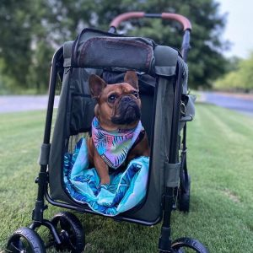

[Bulldog Wagon Stroller](https://ibiyaya.com/product/gentle-giant-pet-wagon/)

## Mobility and Storage Convenience

Modern bulldog strollers are designed with the user’s convenience in mind. They should be easy to fold and lightweight enough to transport and store when not in use. This feature is particularly beneficial for families who enjoy traveling or who frequently transport the stroller in a car.

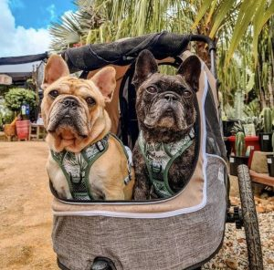

## Conclusion

Investing in a quality dog stroller for bulldog breeds like the English and French Bulldogs allows you to enjoy life’s moments together, from quiet walks in the park to adventurous outings in urban environments. A well-chosen stroller ensures that your beloved bulldog can participate in family activities comfortably and safely, making every trip enjoyable and stress-free. Remember, the right stroller not only caters to the physical needs of your Bulldog but also enhances their overall well-being and happiness.