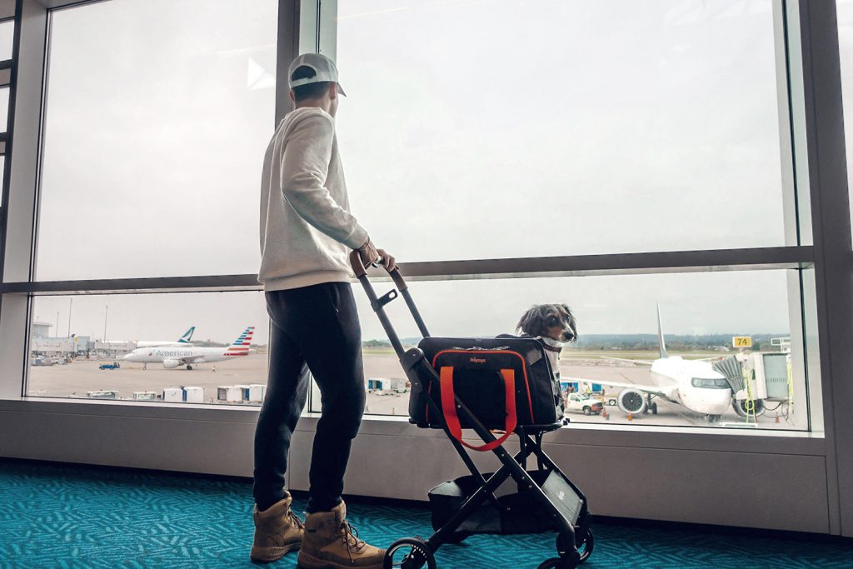

Best Types of Dog Carriers for Airplanes

Traveling with your dog can be an exciting yet challenging experience, especially when flying. Choosing the right dog carrier for airplanes is crucial to ensure both your pet’s safety and comfort throughout the journey. Airlines have specific requirements for pet travel, and understanding these guidelines can make your trip smoother.

In this guide, we’ll explore different types of dog carriers, airline policies, essential features to look for, and tips on preparing your pet for air travel.

 What Are the Dog Carrier Requirements for Air Travel?

When traveling with your pet, it’s essential to choose a soft dog carrier for airplanes that meets airline requirements. Most airlines have specific size and weight restrictions, especially for in-cabin travel. Typically, a small dog carrier for airplanes should fit under the seat in front of you. Soft-sided carriers are preferred since they provide flexibility and comfort for your pet.

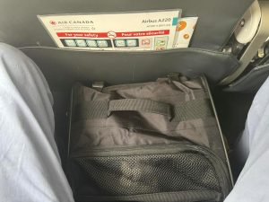  
[JetPaw Expandable Dog Carriers for Airplane](https://ibiyaya.com/product/jetpaw-expandable-pet-carrier-backpack/)

Some general requirements include:

* Must fit under the seat of the cabin.
* Adequate ventilation on all four sides to ensure proper airflow
* Secure closures (zippers, locks, etc.)
* Leak-proof bottom
* Enough space for your dog to stand, turn around, and lie down comfortably

*Some airlines allow slightly larger soft-sided carriers since they can compress to fit.*

It’s always a good idea to check with your airline before purchasing a lightest dog carrier for airplane cabins to ensure compliance.

## Choosing the Right Type of Dog Carrier for Your Travel Needs

With so many options available, selecting the best dog carrier for an airplane depends on your travel needs. Consider these options:

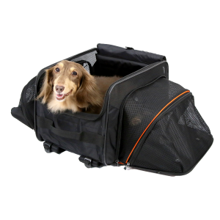

[JetPaw TSA-approved expandable dog carrier for airplanes.](https://ibiyaya.com/product/jetpaw-expandable-pet-carrier-backpack/)

* Soft-Sided Carriers: is a lightweight, flexible bag designed for transporting small pets, especially for airline travel. With mesh ventilation panels for airflow and durable fabric materials like nylon or polyester, its flexibility makes it ideal for in-cabin travel.
* Rolling Dog Carriers for Airplanes:  is a pet carrier with wheels and a telescoping handle, making it easier to transport small dogs through airports. These carriers combine the convenience of a soft-sided pet carrier with the mobility of luggage-style rolling bags.
* Backpack-Style Carriers for Airines: are specially designed pet carriers that allow pet owners to comfortably and securely transport their small pets during air travel. These carriers are worn like a backpack, freeing up the hands and making it easier to navigate through airports, security checks, and tight spaces. They are typically made from lightweight, durable materials and feature padded straps for comfort, mesh panels for ventilation, and secure zippers or buckles to keep pets safe.
* Expandable Carriers: is a pet carrier with zip-out extensions that create extra space for your dog while stationary. These carriers are typically soft-sided, providing comfort, ventilation, and flexibility, making them ideal for air travel, road trips, or vet visits.

 Understanding Airline Dog Boarding Policies

Different airlines have different rules regarding pet travel, so understanding airline dog boarding policy is crucial before booking your flight. Most airlines allow small dogs to travel in the cabin if they are in an airline-approved dog carrier under the airplane seat. Larger dogs usually need to travel in the cargo hold, which has stricter regulations.  
  
Key things to check in your airline’s policy include:

* Allowed carrier dimensions for in-cabin travel
* Pet passport and travel fees
* Required health documents and vaccinations
* Breed restrictions (some airlines do not allow short-nosed breeds like Pugs and Bulldogs due to breathing concerns)

 How to Prepare Your Dog for Long Air Travel?

Before embarking on a long flight, preparing your dog is essential to ensure a smooth journey. Here’s how you can get them ready:

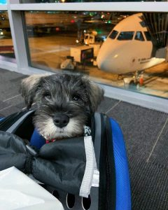  
[Best dog carrier for plane with wheels](https://ibiyaya.com/pet-product/airline-approved-pet-carrier/)

1. Get Your Dog Used to the Carrier Start by introducing your dog to the carrier a few weeks before the flight. Let them explore it, and reward them with treats to create a positive association.
2. Take Short Trips Before the Flight If your dog isn’t used to traveling in a carrier, take them on short car rides to help them adjust.
3. Ensure Proper Identification Attach a tag with your contact details to your dog’s collar. Additionally, you may want to place a label on the carrier with your information.
4. Pack Essentials Bring along a collapsible water bowl, a favorite toy, a blanket with familiar scents, and some treats.
5. Monitor Food and Water Intake Avoid feeding your dog right before the flight to prevent motion sickness. Instead, provide water to keep them hydrated.

How to Calm Your Dog While on a Flight?

Flying can be stressful for dogs, so knowing how to calm a dog while on a flight is important. Here are a few tips:

* Keep Your Dog Comfortable: Placing a familiar blanket or toy in the carrier can help reduce anxiety.
* Use Calming Aids: Some dogs benefit from calming sprays or natural supplements. Check with your vet before the flight.
* Stay Calm Yourself: Dogs can sense your emotions, so maintaining a relaxed demeanor will help reassure them.
* Limit Distractions: Avoid unnecessary stimulation by covering the carrier with a breathable cloth to create a cozy space.

 Features to Look for a Soft Dog Carrier for Airplanes

Choosing the best dog carrier for an airplane depends on several factors, including size, material, and additional features for comfort and convenience. Here are the top features to consider:

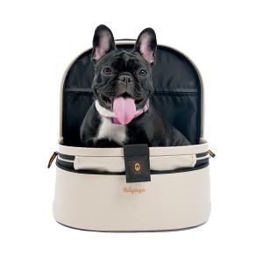

[Panorama Ziffer-Free Dog Carrier for Airplane](https://ibiyaya.com/product/jetpaw-expandable-pet-carrier-backpack/)

* Soft-Sided vs. Hard-Sided: A soft dog carrier for airplanes is generally more flexible and fits better under seats. Hard-sided carriers, on the other hand, offer more protection but may be difficult to accommodate in the cabin.
* Weight: The lightest dog carrier for an airplane is ideal for easy carrying, especially for long airport walks.
* Ventilation: Mesh panels provide airflow, preventing overheating and discomfort for your pet.
* Portability: Rolling dog carriers for airplanes are perfect for those who don’t want to carry the weight on their shoulders.
* Pockets and Storage: Extra compartments help store essentials like treats, a leash, and paperwork.
* Security: Lockable zippers ensure your dog stays safe inside the carrier.

## Final Thoughts

Selecting the right lightest dog carrier for airplanes ensures a stress-free journey for both you and your pet. Understanding airline dog boarding policies, preparing your dog for long flights, and ensuring comfort during travel are key steps to a smooth experience. Choose a carrier that meets airline standards, provides security, and keeps your dog comfortable throughout the trip. Happy travels with your furry companion!