# **How to prevent plaque and tartar in pets: a guide for cat and dog owners**

Plaque and tartar build-up is a common issue for both cats and dogs, and it can lead to painful dental diseases if left untreated. Regular prevention is the best way to avoid these issues and promote long-term health for your pets. Here’s how you can stay ahead of the game and keep your pet’s teeth clean and healthy.



#### **1. Regular Brushing**

Brushing your pet’s teeth is one of the most effective ways to prevent plaque from hardening into tartar. Use a **pet-specific toothbrush and toothpaste** (never human toothpaste!) and aim for a few times a week. For cats, start gently and build up their tolerance slowly, as many felines need time to adjust to brushing.

#### **2. Dental Chews and Treats**

Dental treats are an easy, low-maintenance way to support your pet’s dental health. [**Bell & Bone Cat and Dog Dental Chews**](https://bellandbone.com.au/collections/cat-dental-bites/products/dog-cat-dental-care-bundle-7-pack) are designed to help reduce plaque and tartar while being delicious for your pet. These vet-recommended treats are specially formulated to clean teeth and gums as your pet chews, providing daily protection against plaque build-up.

#### **3. Proper Diet**

Feeding your pet a well-balanced diet with a mix of high-meat content, raw or air-dried foods that contain low starch can also play a role in their dental health. This complete and balanced diet helps scrape off plaque, while certain ingredients found in pet food, like chlorophyll or enzymes, can reduce plaque-causing bacteria.

#### **4. Regular Vet Check-Ups**

Just like humans, pets need routine dental check-ups to ensure their teeth and gums are in good shape. Your vet can spot early signs of plaque, tartar, or dental disease and provide professional cleaning if necessary. Regular vet visits are crucial, especially for older pets.

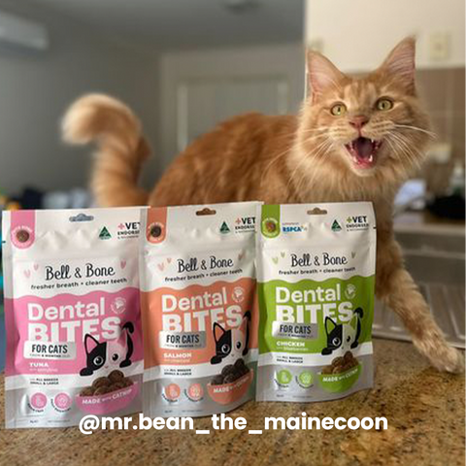

### **The Importance of Early Prevention**

Dental disease starts with plaque but can quickly escalate into more serious health concerns if not addressed. By combining at-home care with vet-recommended products like [**Bell & Bone Cat Dental Bites**](https://bellandbone.com.au/collections/cat-dental-bites/products/cat-dental-bites-bundle-3-pack-1), you can protect your pet’s oral health and reduce the need for costly treatments later. Bell & Bone Cat Dental Bites are safe for cats 6 months and older, once kitten teeth have fallen out.