# **DIY Dental Food for dogs & cats: The first gut-health Dental Topper Spray in Australia**

Discover our new [**Bell & Bone Dental Topper**](https://bellandbone.com.au/collections/dental-toppers) – the **first gut-focused dental spray for dogs and cats**. This vet-approved solution is designed to support oral and gut health in one simple step. Developed by Bell & Bone’s founder Arianne over five years of research and dedication, it's here to transform dog and cat health and wellness for good.

### **What Is the Bell & Bone Dental Topper?**

The Bell & Bone Dental Topper is Australia’s first gut-focused dental spray for dogs and cats. Backed by science and designed by experts, this easy-to-use food topper supports both oral hygiene and digestive health, preventing dental disease before it starts.

In just four sprays a day, you can turn your pet’s regular meal into a powerful DIY dental food packed with [oral actives, probiotics, prebiotics, and postbiotics](https://bellandbone.com.au/blogs/gut-dental-health/the-science-of-diy-dental-food-how-a-healthier-gut-will-transform-your-pet-s-mouth).

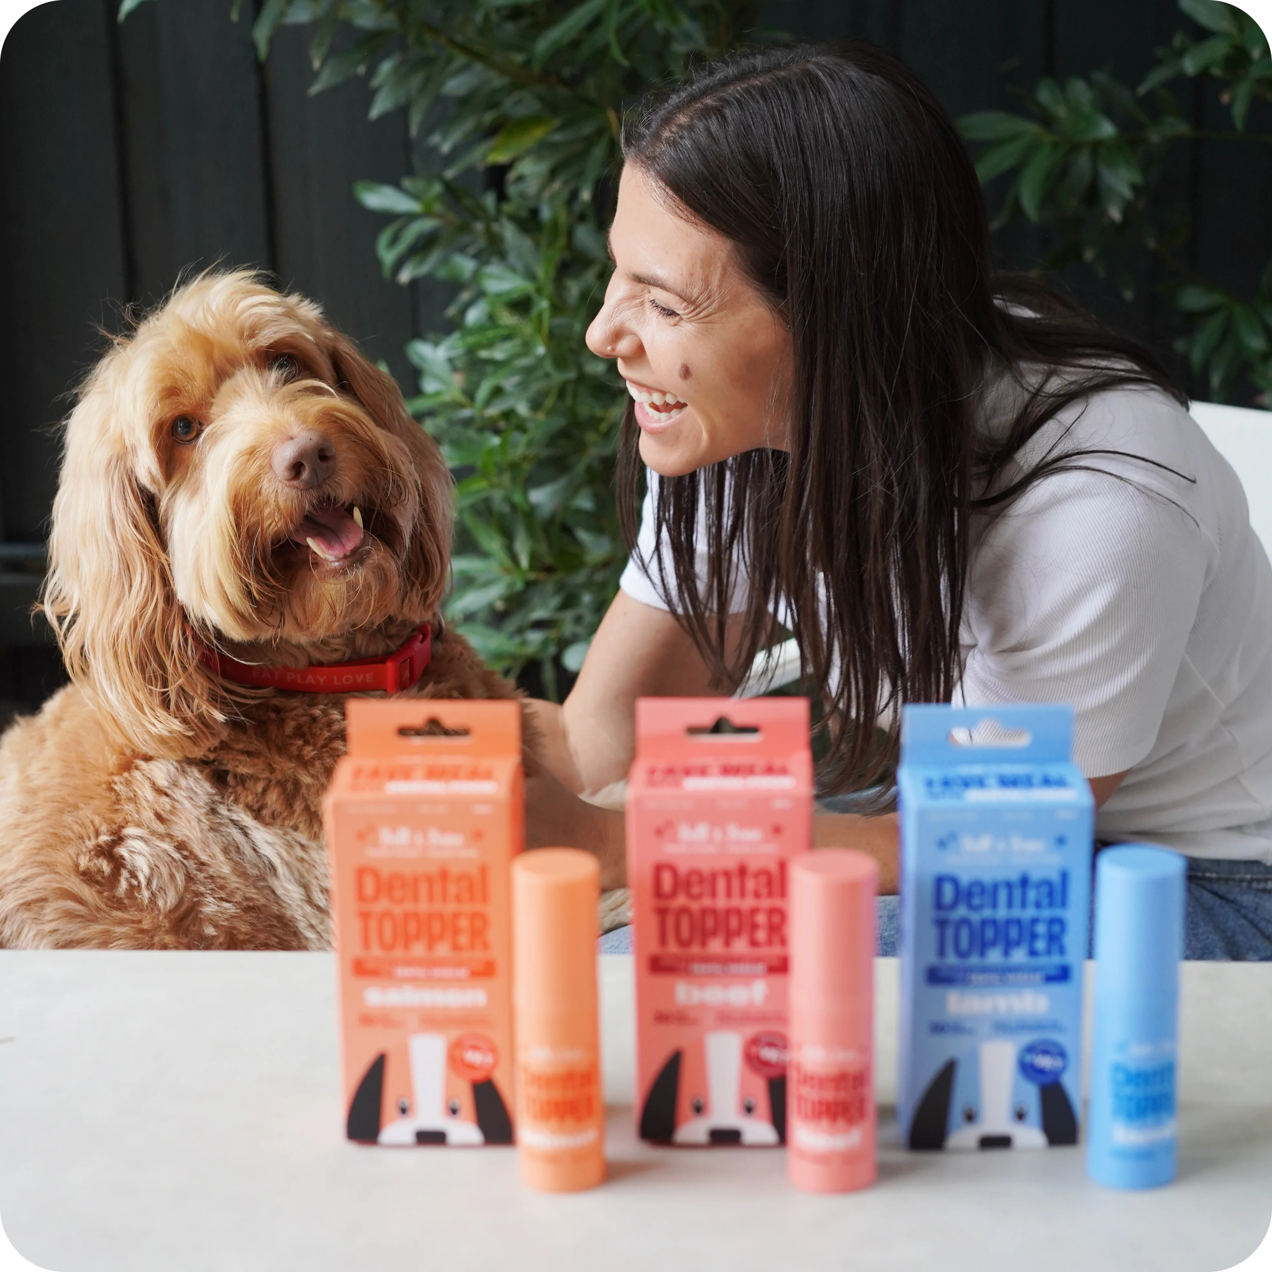

### **Arianne’s Story: Why I Created the Bell & Bone Dental Topper**

*“Hi, I’m Arianne – the founder of Bell & Bone. Over the past five years, I’ve been on a mission to change how we approach pet dental care.*

It all started when I learned that dental disease shortens a pet’s life by up to 30%, and that nearly 80% of pets suffer from it by age three. I was shocked… So I developed our [best-selling Dog Dental Sticks](https://bellandbone.com.au/collections/dental-sticks-1) and [Cat Dental Bites](https://bellandbone.com.au/collections/cat-dental-bites).

Our Dental Sticks for dogs and Dental Bites for cats are **Australia’s first natural and effective dental treats**. With a meat-first formula packed with active ingredients, they prevent and reduce dental issues through mechanical abrasion. They're not just effective but also delicious daily treats! The positive feedback has been incredible—just [check out the glowing reviews](https://bellandbone.com.au/#:~:text=See%20what%20our%20B%26B%20pets%20have%20to%20think!)!

However, with **80% of dogs and 70% of cats still facing dental disease**, I became obsessed with uncovering WHY. I was determined to change these alarming statistics for good!

##### ***I knew we needed to go deeper.***

That’s when I began working with leading vets and experts to uncover the real cause of dental disease in pets. What we found was eye-opening: **the gut plays a critical role in oral health**. A healthy gut microbiome helps prevent the overgrowth of harmful bacteria, which is the starting point for plaque, tartar, and inflammation.

So, I dedicated myself to creating a product that not only cleans teeth but prevents disease at the source—the gut. After years of research, testing, and collaboration, the **Bell & Bone Dental Topper** was born."

### 

### **Why Gut Health Matters for Pet Dental Care**

An unhealthy gut is one of the hidden causes of dental disease in pets. An imbalanced microbiome allows harmful bacteria to thrive, which leads to:

* Plaque and tartar buildup
* Bad breath
* Gum inflammation
* Tooth decay

By improving gut health, the Dental Topper tackles the root cause of dental disease—from the inside out.

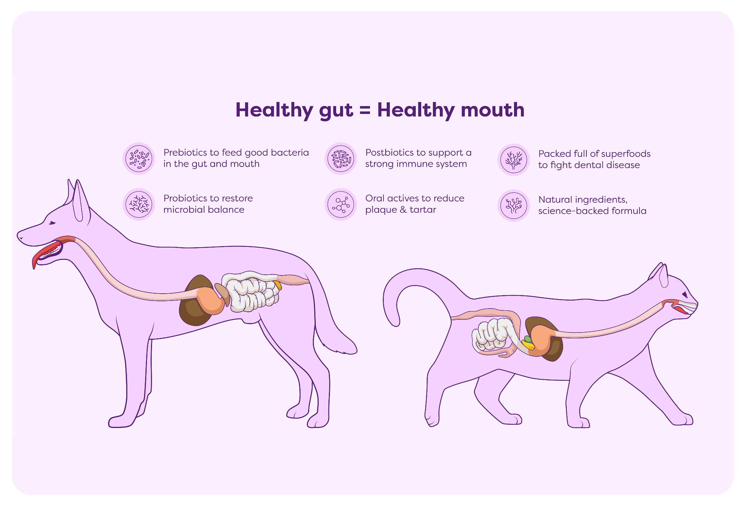

### 

### **Key Benefits of the Bell & Bone Dental Topper**

* ✅ Targets oral and gut health: Combats plaque, bad breath, and inflammation
* ✅ Vet-approved for dogs and cats: Safe for daily use across all life stages
* ✅ Easy to use: 4 sprays per day, no brushing required
* ✅ 30-day supply: Long-lasting support for oral care
* ✅ Backed by real results: 97% of trial pets showed improvements in breath, gums, teeth (and even stools)!

### 

### **Dental Topper vs Powder: Why Spray Works Better**

Powder toppers often lose their probiotic benefits during processing. Our topper liquid spray format keeps these bacteria active and effective. Here’s why that matters:

| **Feature** | **Dental Topper (Spray)** | **Powder Toppers** |
| --- | --- | --- |
| **Preserves probiotics** | ✅ Yes | ❌ No |
| **Easy daily application** | ✅ 4 sprays | ❌ May require mixing |
| **Long-lasting** | ✅ 30-day supply | ⚠️ Varies |
| **Vet-recommended** | ✅ Yes | ⚠️ Often not tested |

### **How the Bell & Bone Dental Topper Works**

The secret powerful combination of:

* **Oral actives:** Break down plaque, freshen breath, and support healthy gums
* [**Tribiotic blend of Prebiotics, Probiotics & Postbiotics**](https://bellandbone.com.au/blogs/gut-dental-health/the-science-of-diy-dental-food-how-a-healthier-gut-will-transform-your-pet-s-mouth)**:** Balance gut flora and reduce inflammation that causes dental disease
* **Superfoods:** Kelp, turmeric, blueberry, green tea, and green-lipped mussel for total wellness

### 

### **The Ultimate Dental Care Routine for Pets**

For best results, pair the Dental Topper with Bell & Bone Dental Sticks (dogs) or Dental Bites (cats).

* **🐶 Dental Sticks & 🐱 Dental Bites:** Clean teeth through mechanical abrasion while delivering delicious, meat-first nutrition
* **Dental Topper Spray:** Reinforces dental and gut health from within

Together, they provide a full-spectrum approach to pet dental care—ensuring cleaner teeth, fresher breath, and longer lives.

### 

### 

### **Daily Dental Care Made Easy**

* ✅ Shake the bottle
* ✅ Spray 4 pumps on your pet’s food
* ✅ Watch their gut and dental health improve with every meal

***No muss. No fuss. Just better health.***