Baked Kibbles: The Game-Changer in Pet Food

Introduction: A New Era of Pet Kibbles
Pet food has changed dramatically during the past few decades. As pet owners become more conscious of their furry companions' health, the demand for healthier alternatives in both dog food and cat food has skyrocketed. Among the most exciting innovations in pet nutrition is the rise of baked kibbles—a revolutionary approach that preserves more nutrients and enhances digestibility. Baked kibbles are a revolution in pet food since they have a stronger nutritional profile and a better taste than regular extruded kibbles.

What Are Baked Kibbles?
High-temperature extrusion is used in the production of conventional kibble, which may reduce essential nutrients. The slow cooking of baked kibble at lower temperatures, on the other hand, helps preserve the vitamins, minerals, and amino acids that are essential for a pet's health.
This mild baking method improves the food's flavor and texture while preserving nutrients. Additionally, because baked kibbles are simpler to digest, there is a lower chance of gastrointestinal problems that are frequently linked to highly processed pet food.
This offers pet owners who appreciate natural, premium pet food a safe and sensible choice.

The Nutritional Benefits of Baked Kibbles
Baked kibbles offer significant health advantages that distinguish them from traditional dry pet food.
- Retains More Nutrients – The low-temperature baking process helps maintain the integrity of essential nutrients, ensuring that pets receive a diet rich in vitamins and minerals.
- Easier Digestion – The slow baking process naturally breaks down starches, making baked kibbles more digestible and gut-friendly.
- Enhanced Flavor – With natural, oven-baked goodness, these kibbles are more palatable, and appealing to the pickiest pets.
- Improved Dental Health – The crunchy texture of baked kibbles helps scrape away plaque and tartar buildup, contributing to better oral hygiene for dogs and cats.
- Balanced Energy Levels – The slow-cooked process allows carbohydrates to break down in a way that provides a steady release of energy, reducing spikes and crashes in pets’ activity levels.
Baked Kibbles vs. Traditional Kibbles: What's the Difference?
As more pet owners realize the value of premium dog and cat food, more are choosing baked kibbles. Baked kibbles stack up differently than conventional extruded kibbles here:
Feature |  | Traditional Kibbles | Baked Kibbles
Cooking Method |  | High-temp extrusion | Slow baking
Nutrient Retention |  | Lower | Higher
Digestibility |  | Moderate | High
Taste |  | Standard | More flavorful
Preservatives |  | Often required | Minimal or none
Shelf Life |  | Shorter | Longer
As pet owners become more educated on nutrition, many are opting for baked kibbles due to their superior quality and digestibility. The transition towards minimally processed pet food reflects a growing awareness of the role nutrition plays in pet health and longevity.

How to Choose the Best Baked Kibbles for Your Pet

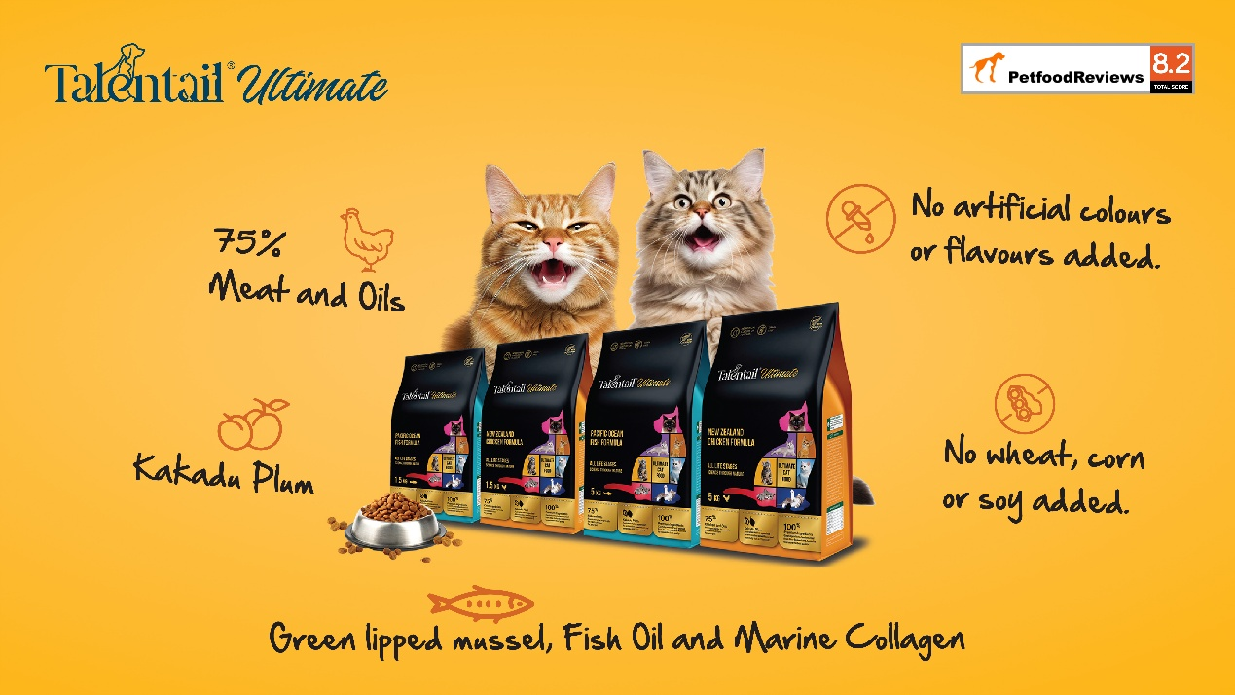
There are now a lot of options on the market due to baked kibbles' growing popularity. When choosing the best baked kibble for your pet, keep the following important elements in mind:
- Check the Ingredient List – Look for whole meats, vegetables, and healthy grains. High-quality proteins should be the first ingredient.
- Avoid Artificial Additives – Choose products free from artificial colors, flavors, and preservatives to ensure your pet gets the best nutrition possible.
- Consider Dietary Needs – Whether your pet requires grain-free options, high-protein formulas, or specific nutrients for their health conditions, select a product that aligns with their unique dietary needs.
- Look for Transparency in Sourcing – The best pet food brands provide clear information about where their ingredients come from and how their products are made.
- Check for Omega Fatty Acids – Healthy fats, such as omega-3 and omega-6, contribute to a shiny coat, strong immune system, and overall well-being.

Talentail is among the top baked kibble products available now on the market. Talentail presents a great and healthy dinner for dogs and cats made with premium, all-natural ingredients. Rich in premium proteins including New Zealand fresh chicken meat and gut-friendly components like Kakadu plum. This baked kibble is meant to support pets' best possible vitality and health.
Apart from its better nutritional value, Talentail is among the cleanest pet food choices since it is free of artificial preservatives, fillers, and byproducts. Talentail offers a well-rounded meal catered to their particular dietary requirements regardless of the kind of pet you have—puppy, kitten, or elderly.
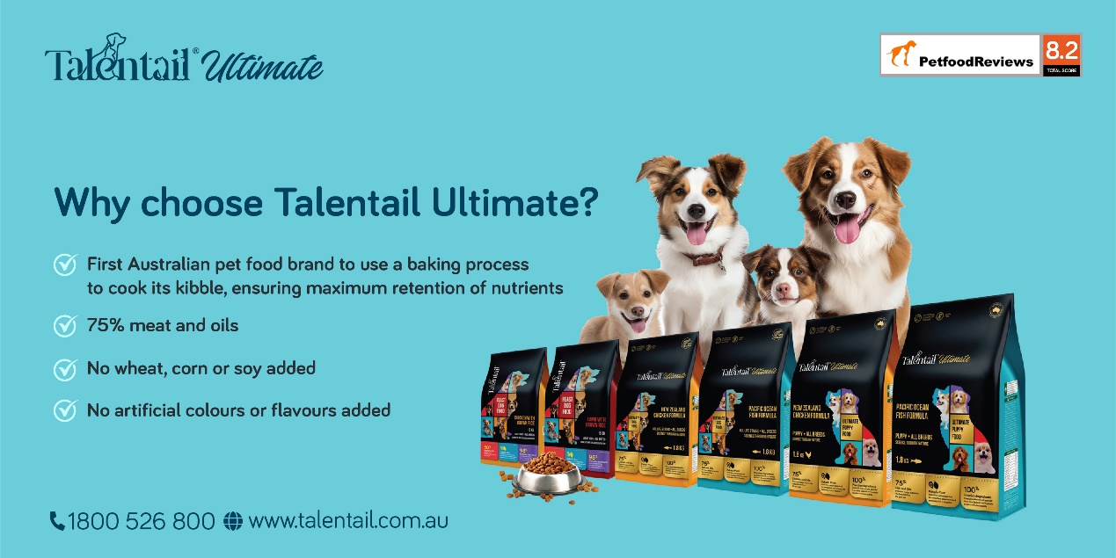
Conclusion: A Smarter Choice for Pet Nutrition
Giving pet owners a better substitute for conventional extruded kibbles, baked kibbles are revolutionizing the pet food market. Better nutrient retention, digestibility, flavor, and extra health advantages make them a complete pet food that suits our pets’ taste and health.
Start using baked kibbles immediately and personally see the advantages. See Talentail ultimate to provide your pet with the greatest nutrients they are due!
Follow us on social media for pet nutrition tips, product updates, and more!

Reference:
Gibson, M. W., & Sajid, A. (2013). Pet food processing: understanding transformations in starch during extrusion and baking. Cereal Foods World, 58(5), 232-236.
Gibson, M. W. (2015). Physico-chemical and shelf-life between baked and extruded pet foods (Doctoral dissertation, Kansas State University).
Pame, K., Sathu, T., Vasudevan, V. N., Prajwal, S., & Gunasekaran, P. (2018). The Effects of Baking Process and Inclusion of Processed Animal Byproducts on Pet Kibbles Nutrition, Palatability and Texture Characteristics. Indian Vet. J, 95(03), 26-30.

