Biogone Dog Products Now 20% Off

You’re the early risers hitting the trails with our four-legged best mates.
You’re the local councils working hard to keep parks and public spaces clean.
You’re the dog groomers, walkers, and pet stores who need quality, reliable stock at the right price.
Now, for a limited time, during the ‘Click Click Boom Sale’, we’re making it super easy for you to grab what you need—20% off all our doggo products, including our top-rated landfill-biodegradable dog waste bags.

Why Choose Biogone Products?
We’re proud to offer dog waste bags that don’t just get the job done—they do it better for the planet. Here’s why our landfill-biodegradable waste bags are a smart switch:
- These bags biodegrade 90% faster in landfills than conventional plastic.
- Tough and leak-proof (because no one wants a messy surprise).
- Same convenience, better conscience.
- Compatible with our dispensers, available in personal and public-use sizes.
We believe small swaps make a big difference. Our landfill-biodegradable and home compostable dog waste bags help reduce long-term waste without sacrificing quality or function.

Landfill-Biodegradable Dog Waste Bags
Our durable, leak-proof dog waste bags make clean-up quick and hygienic, ensuring your hands stay clean and odour-free. Easy to open, separate, and tie, they’re designed to accommodate waste from dogs of all sizes. With no shelf-life issues, you’ll never face unexpected tearing. Each roll contains a cardboard core, fitting perfectly into our dispensers and standard holders—ideal for grabbing on your next walk. These bags biodegrade 90% faster in landfills than conventional plastic.

BIODEGRADABLE DOG WASTE BAG — 4 PACK (80 BAGS)
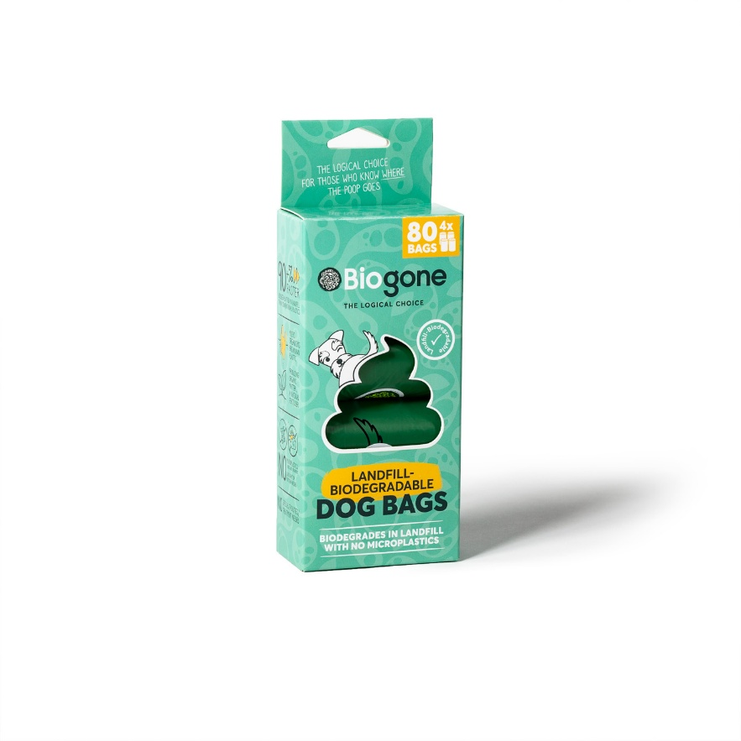

BIODEGRADABLE DOG WASTE BAG — 8 PACK (160 BAGS)
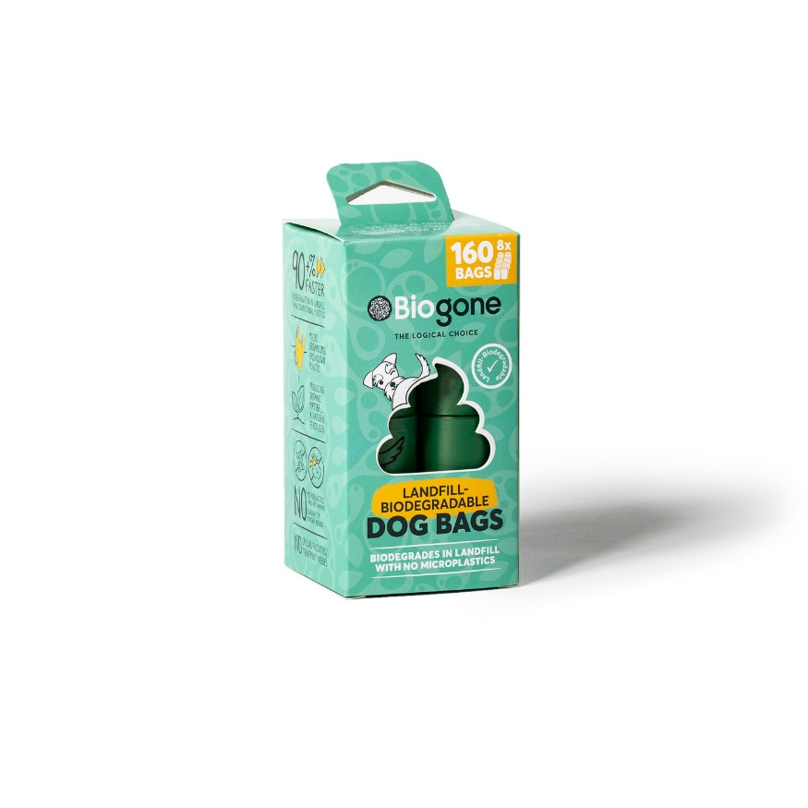

BIODEGRADABLE DOG WASTE BAG W/HANDLE — 1 LGE ROLL (250 BAGS)
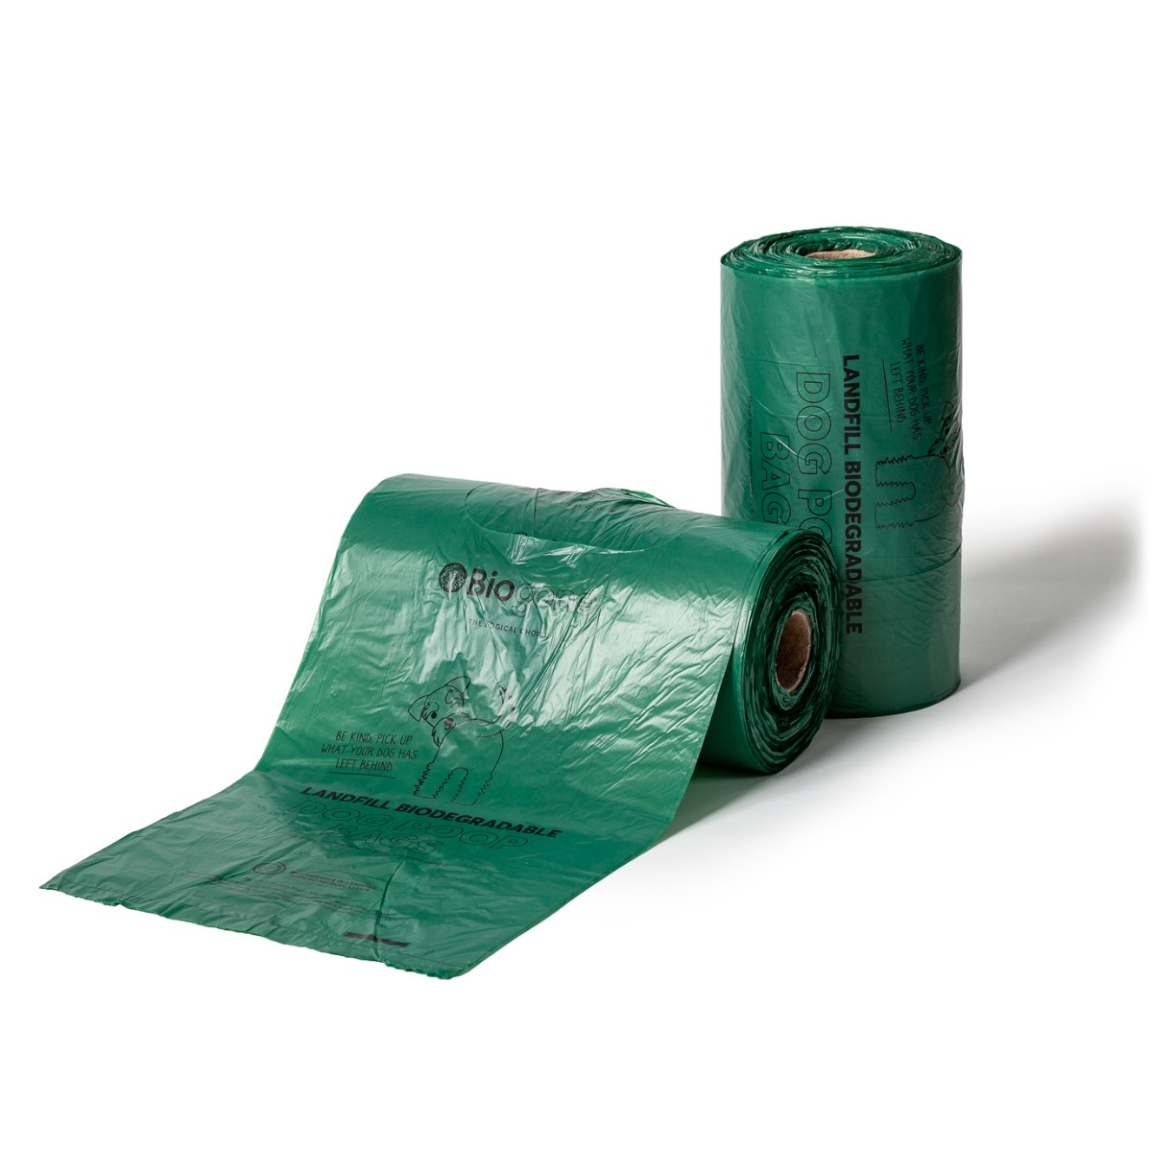

Home Compostable Dog Waste Bags
Our certified home compostable dog waste bags make clean-up quick and hygienic, ensuring your hands stay clean and odour-free. Easy to open, separate, and tie, they’re designed to accommodate waste from dogs of all sizes. Made from durable, non-toxic, plant-based materials, they will break down fully in home compost or landfill conditions.

HOME COMPOSTABLE DOG WASTE BAG 225 X 10 ROLL (BP)
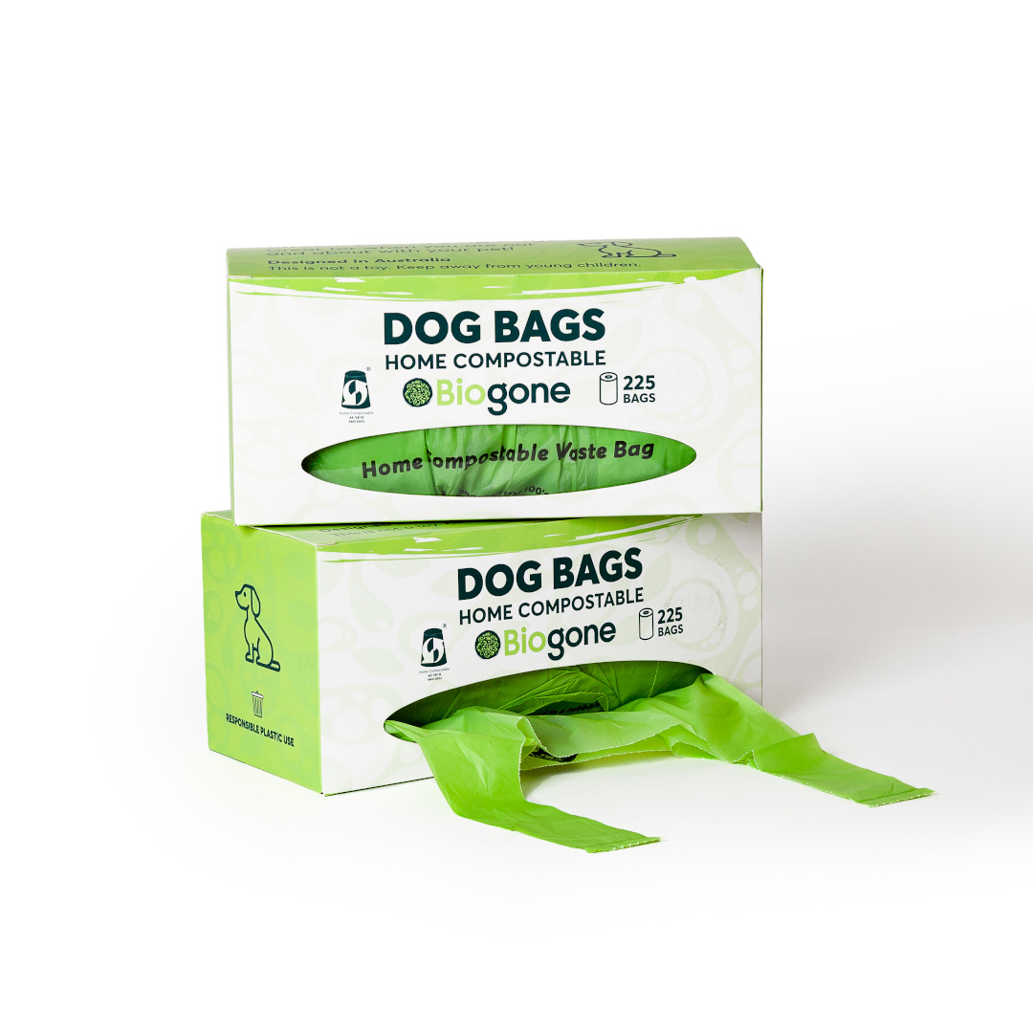

HOME COMPOSTABLE DOG WASTE BAG — 4 PACK
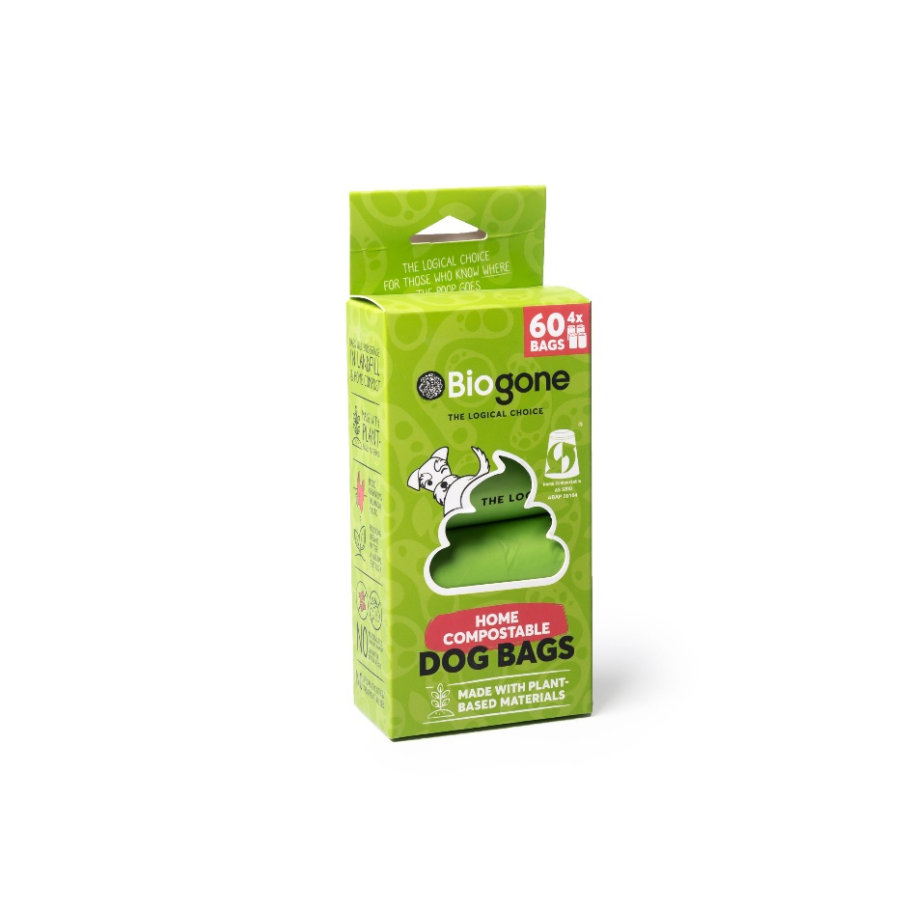

HOME COMPOSTABLE DOG WASTE BAG — 8 PACK
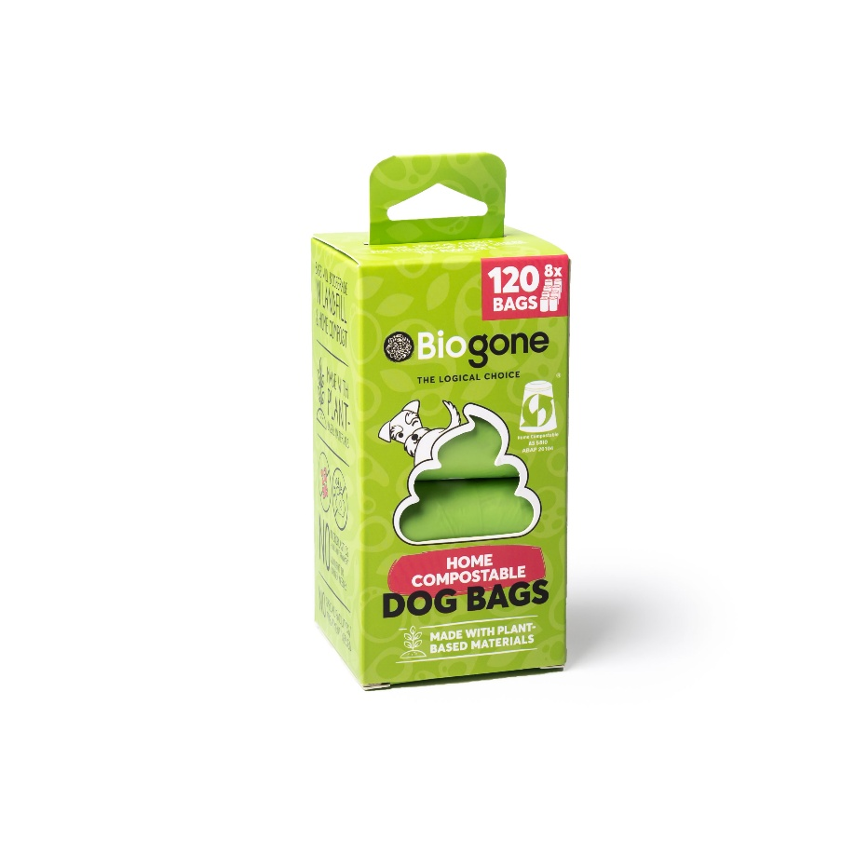

Stock up and save during the Click Click Boom Sale!
Whether you're a dog owner, a pet professional, or part of a council or park management team, this is our chance to say thank you—to everyone doing the right thing and cleaning up after their pets and thinking about the planet while they do it.
Show the planet (and your furry friend) some love.
All Biogone dog products available now at 20% off for a limited time only.

